For each question from 16 te 20, choose the word(s) clasest in meaning to the underlined word(s).  
Shade your answer (1, 2, 3 or 4) on the Optical Answer Sheet.

(2 Marks)

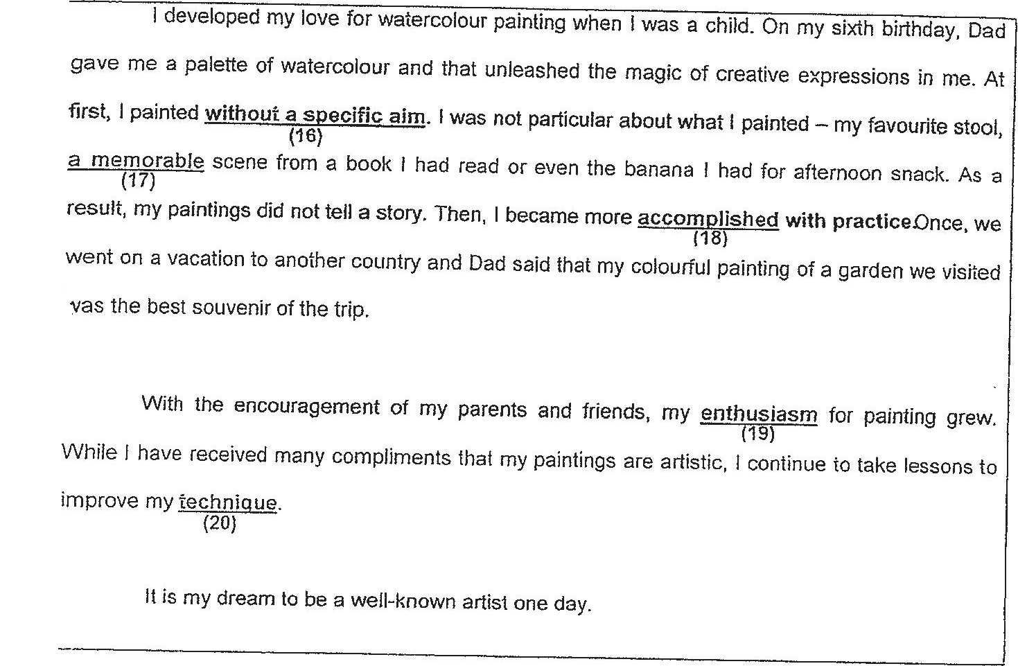

vas the best souvenir of the trip.

improve my feabrue  
{20}

iis my dream to be a well-known artist one day.

46 (1t} curiously  
(2) randomly  
(3) recklessly  
(4) relentlessly

V7 (4) an undenable  
(2) an irremovable  
(3) an unbelievable  
(4) an unforaeitable

16 (1) adept  
(2) perfect  
(3) correct  
(4) accurate

(Se on to tne sexi cae